- Open ProXR, Select Com Port 5, Baudrate 9600, and R4xPro/R8xPro, then click OK.

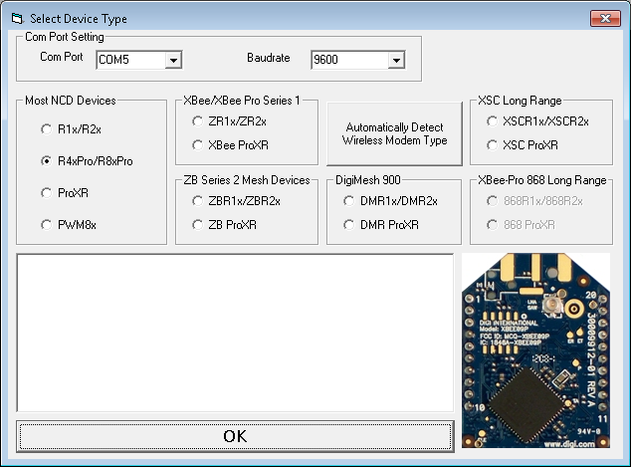

- Click Test 2-Way Communication, the ??? should turn to PASS, if not contact Beena Vision for help.

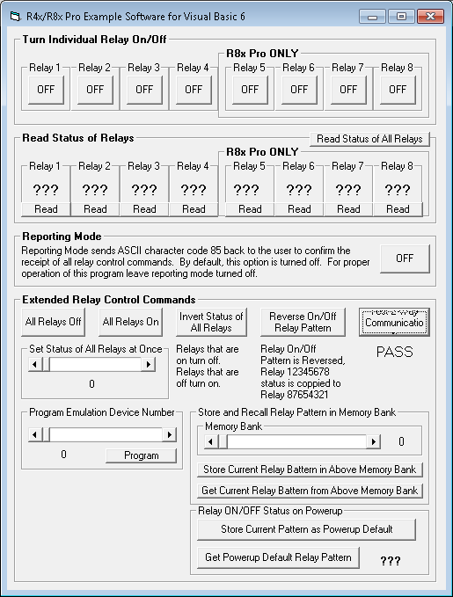

- Kill the TD40_SysmonInterface Module in the Beena Vision Task Manager.

- Open hypertrm.exe under C:/HyperTerminal.

- Type any name, then press OK.

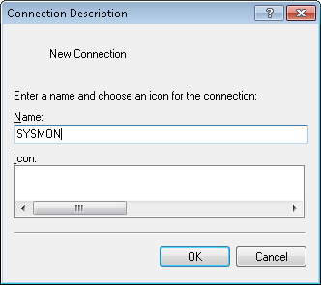

- If flashing the SYSMON select COM4, if flashing the TRIGGER select COM3, then press OK.

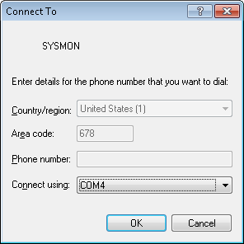

- Select Bits per second: 19200, and Flow control: None, then press OK.

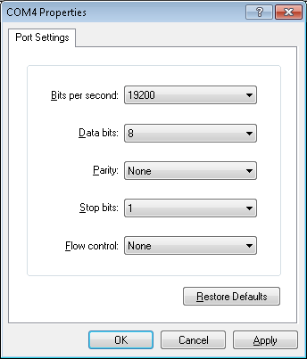

- Return to ProXR.
- If flashing SYSMON, click OFF under Relay 3, it will turn to ON, then click OFF under Relay 4, it will turn to ON, then click ON under Relay 3, it will turn to OFF.
- If flashing TRIGGER, click OFF under Relay 1, it will turn to ON, then click OFF under Relay 2, it will turn to ON, then click ON under Relay 1, it will turn to OFF.

- Return to HyperTerminal, you should see the following text:

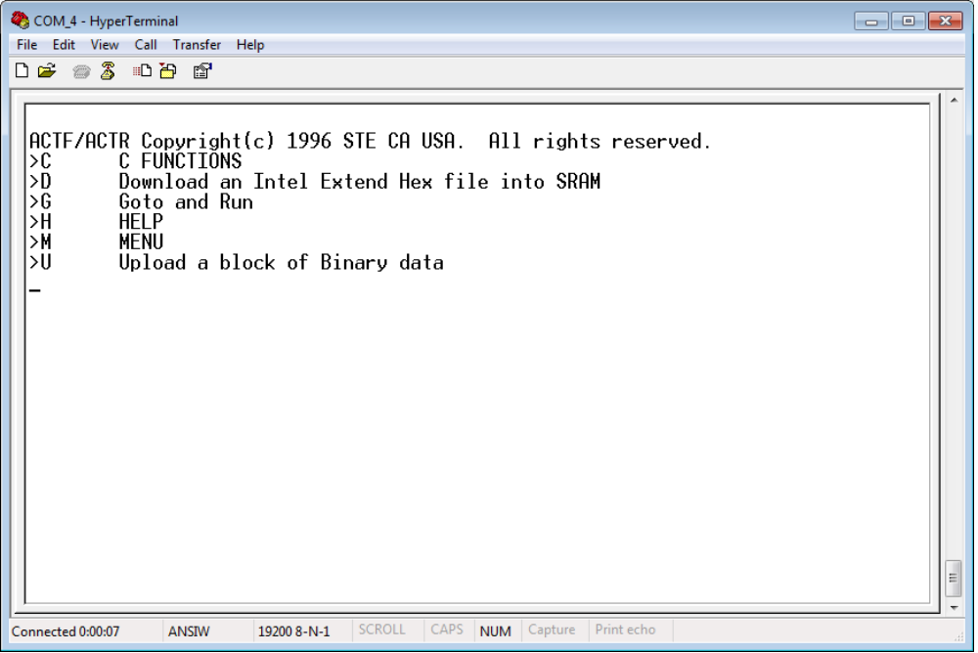

- Type 'D' (Shift+d) and press Enter. You will then see a message saying “Ready to recieve Intel Extend HEX file at 19200 baud.”

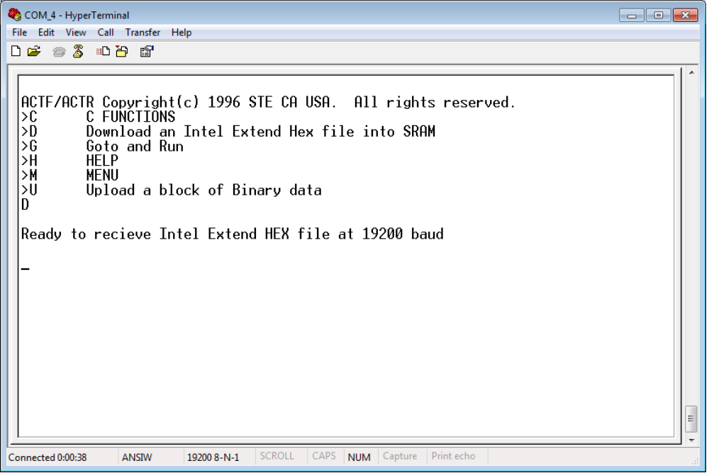

- Click the 'Transfer' button in the menu at the top of the window, then select 'Send Text File...'

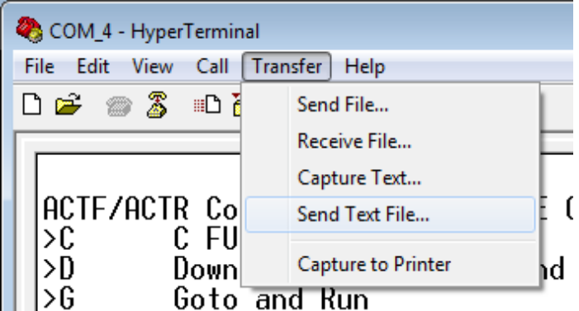

- Navigate to C:/TD40 and select 'All files (*.*)' from the dropdownlist at the bottom-right of the window, click on the file named LO_EE128.HEX, then click the 'Open' button. This will erase the memory of the existing firmware in the FLASH ACTF chip within the TD40.

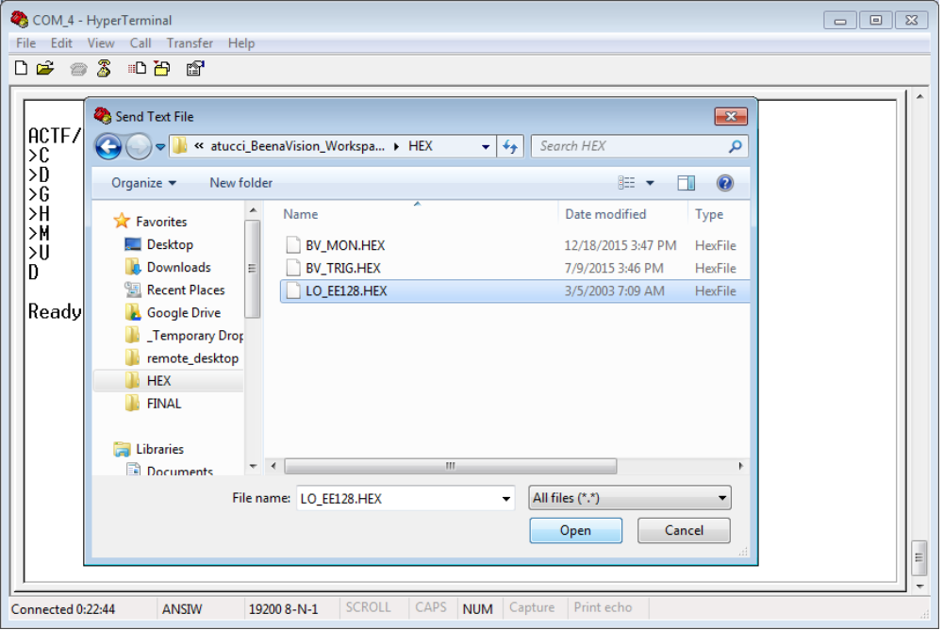

- You will see many 'U' response characters coming back from the TD40. Wait for all of them to come in before doing anything else. This will take approximately 10 to 15 seconds. When this process is finished, you will get a command prompt.

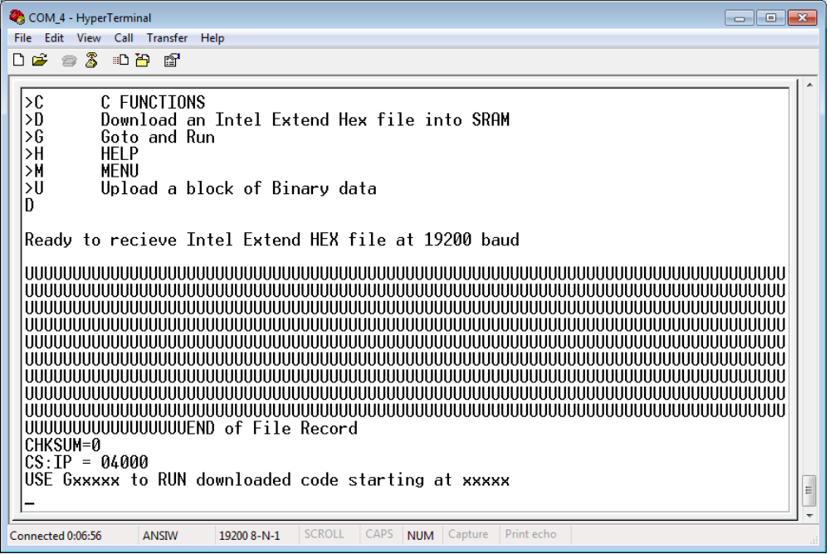

- At the command prompt, type G0400 and press Enter. After a couple of seconds the message 'Ready to receive 'APP.hex' file and program it into the Flash (AMD29F010) !' will appear.

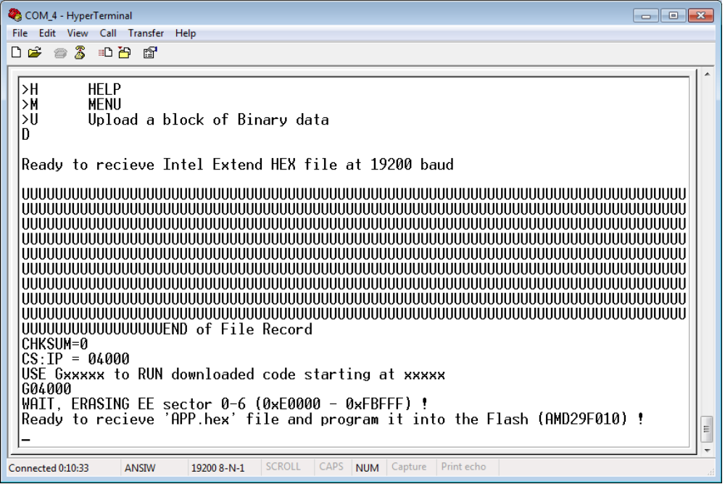

- Repeate Step 11........Click the 'Transfer' button in the menu at the top of the window, then select 'Send Text File...'

- Navigate to C:/TD40 and select 'All files (*.*)' from the dropdownlist at the bottom-right of the window, click on the firmware .HEX file you wish to program into the TD40, then click the 'Open' button. This step will load the desired firmware in the FLASH ACTF chip within the TD40.

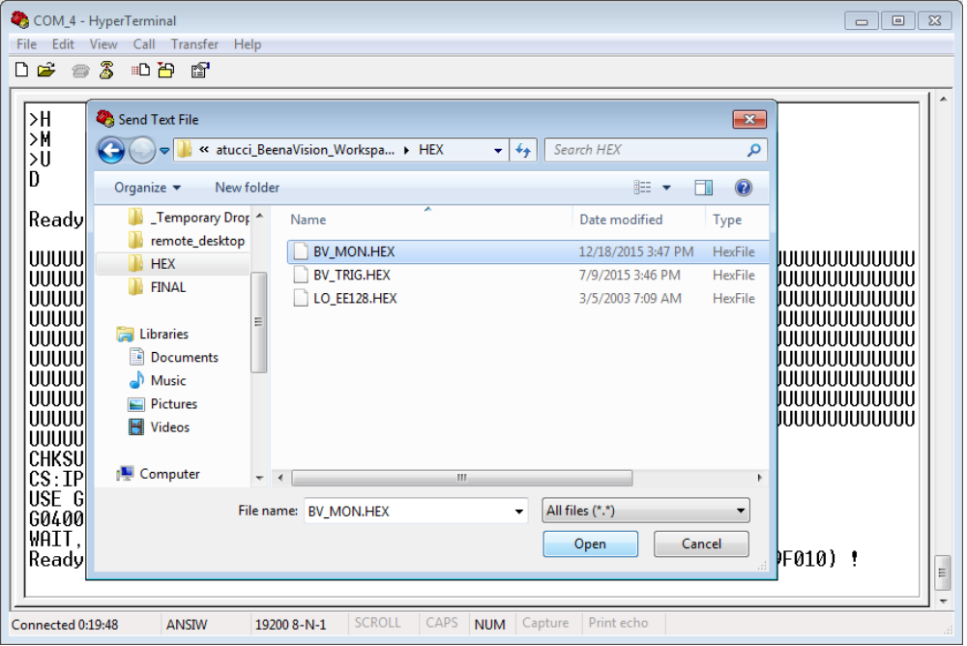

- You will see many 'V' response characters coming back from the TD40. Wait for all of them to come in before doing anything else. This could take anywhere from 30 seconds to two minutes, depending on the size of your firmware file. When this process is finished, you will get a command prompt.

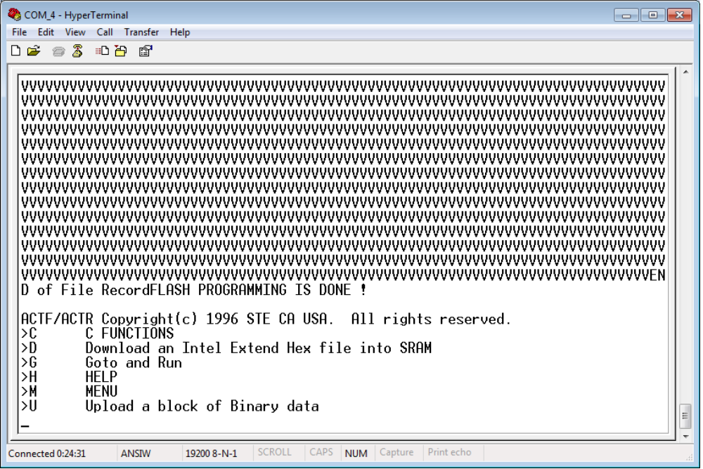

- At the command prompt, type G0400 and press Enter. You are now finished programming the firmware. You will not see any further messages after pressing Enter, just a command prompt. You are finished with the HyperTerminal application and can close it.

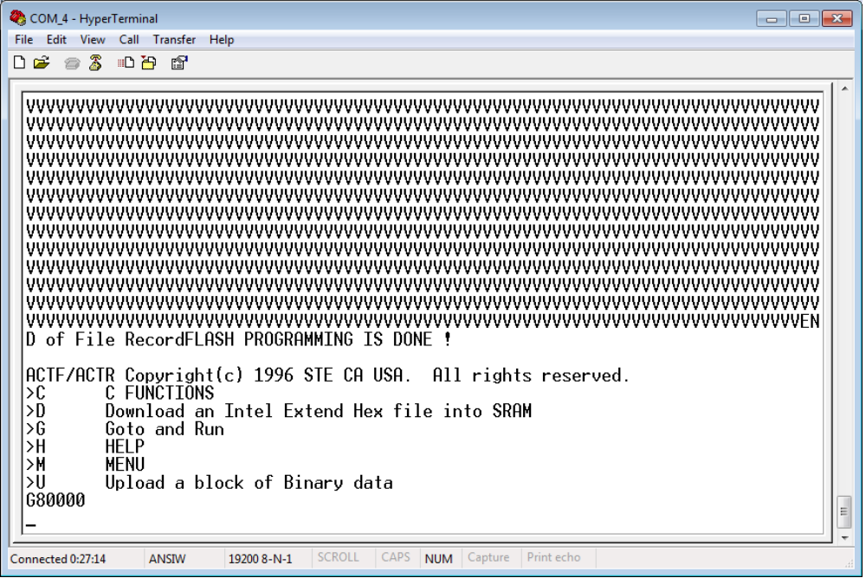

- Return to ProXR. (This step is SLIGHTLY DIFFERENT than step 8)
    - If flashing SYSMON, click OFF under Relay 3, it will turn to ON, then click ON under Relay 4, it will turn to OFF, then click ON under Relay 3, it will turn to OFF.
    - If flashing TRIGGER, click OFF under Relay 1, it will turn to ON, then click ON under Relay 2, it will turn to OFF, then click ON under Relay 1, it will turn to OFF.

- Step 19 restored the jumpers and power to the TD40. You are now completely finished with the process of reprogramming firmware into the TD40.

- Restart the Beena Vision Task Manager and wait for the 'TD40 communication established' message to appear in the Event Log pane. This message confirms the firmware was programmed successfully and everything is working properly withing the TD40. If, instead, you receive the 'TD40 communication error' message, please contact a Beena Vision software administrator for further assistance.

